Fluoride Varnish Application Information

Patient Specific Direction (PSD): Fluoride Varnish Application
The NHS dentistry: quality and payment reforms contractual guidance states that
“Clinicians should take into account the guidance on the validity of a Patient Specific Direction (as described on the Specialist Pharmacy Services webpage) when considering the start and finish date of the direction”.

This guidance advises that whilst not defined in legislation a Patient Specific Direction (PSD) is the traditional written instruction, signed by a prescriber for medicines to be supplied and/ or administered to a named individual after the prescriber has assessed that individual on a one-to-one basis.

In practice a PSD is commonly referred to as a prescription by those who write them or use them as the legal basis to administer a medication because this indicates that it is written by a prescriber.

A patient Specific Directive should contain the drug, dose, and route of administration.
So, for example, for Fluoride Varnish:
- Use a 2.26% Sodium Fluoride Varnish Licensed for Caries Control. Apply to all surfaces of teeth (or quote particular teeth if full mouth application not required).
- Recommended dosage for single application
0.25ml Primary dentition (2-5 years)
0.4ml Mixed dentition (5-16)
0.75ml Permanent dentition (16+)

Example PSD
An appropriate PSD for a child in the mixed dentition who is having fluoride varnish applied by a dental nurse in 3/12 would be:
Name: xxx
Apply: 0.4ml 2.26 sodium fluoride varnish licensed for caries control to all tooth surfaces in 3 months
Signature: xxx

Further Information:
Note Chapter 9 of the NHSE guidance Delivering better oral health: an evidence-based toolkit for prevention states ‘Clinicians should be aware that many fluoride varnishes on the market are not licensed for dental caries control, although they may have similar formulations, and take this into consideration with respect to their prescribing responsibilities.’
https://www.gov.uk/government/publications/delivering-better-oral-health-an-evidence-based-toolkit-for-prevention/chapter-9-fluoride

Summary of Product Characteristics are detailed here https://mhraproducts4853.blob.core.windows.net/docs/d8fd972fdd155a807445b4f73fdcbb9782f900c9
Therapeutic indications - For the prevention of caries in children and adults as part of a comprehensive control programme. For the: -
- prevention of recurring (or marginal) caries
- prevention of progression of caries
- prevention of decalcification around orthodontic appliances
- prevention of pit and fissure (occlusal) caries
- prevention of dental caries in all children aged 3 to 18 years: Apply fluoride varnish (2.26% NaF) to teeth 2 times a year
- prevention of dental caries in children aged 0 to 6 years giving concern because of dental caries risk: Apply fluoride varnish (2.26% NaF) to teeth 2 or more times a year.
- prevention of dental caries in children from 7 years and young people up to 18 years giving concern because of dental caries risk: Apply fluoride varnish to teeth 2 or more times a year (2.26% NaF).

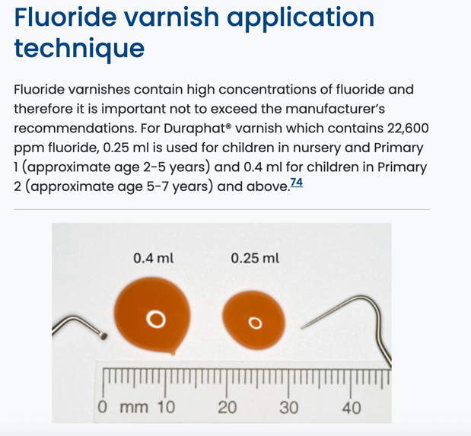

Consider prescribing high fluoride toothpaste where appropriate to prevention of dental caries in adults giving concern because of dental caries risk: For those with obvious active coronal or root caries, consider prescribing 2,800 or 5,000ppm fluoride toothpaste until dental caries is stabilised and risk is reduced.

NHS dentistry: quality and payment reforms contractual guidance

7. Fluoride varnish treatment by dental nurses

7.1 Background
Fluoride varnish is a highly effective preventative treatment for dental caries in both permanent and primary teeth.
Delivering Better Oral Health recommends routine application of fluoride varnish in children. Specifically, it is recommended that those identified as being at higher risk of dental caries receive fluoride varnish treatments at least 4 times per year.
Similarly, children at lower risk of caries are advised to have fluoride varnish applied 2 times per year. These recommendations aim to support consistent, comprehensive caries prevention across all risk groups, thereby promoting improved oral health outcomes for children and adolescents.
To support Dental Practices in providing this treatment to children aged 16 and under, suitably competent dental nurses will be able to apply fluoride varnish without a dental examination from 1 April 2026. This will be introduced as a new Band 1 (standalone fluoride varnish) course of treatment to be provided under prescription.
Fluoride varnish can still be provided by dentists, hygienists and therapists as part of a Band 1 course of treatment, outside of the 3-month window before or after a fluoride varnish treatment delivered by a dental nurse (see section 7.3 for further detail).
However, this contract change will allow Dental Practices to make greater use of their skill-mix. It supports the efficient, higher-volume delivery of this preventative measure by dental nurses at times convenient to families with children, for example, evenings or weekends in addition to normal surgery hours.

7.2 Setup of dental nurses in the Contract Management and Payment System
Dental nurses will be allowed to act as direct access Dental Care Professionals (DCPs) for the provision of fluoride varnish under a prescription. This will enable dental nurses to independently open and close this Band 1 course of treatment in systems for children up to 16 years old.
Dental nurses providing this course of treatment must have a personal identification number (PIN) and be added to the list of clinicians employed on the contract in the Contract Management and Payment System.
The process for assigning a PIN is the same as for hygienists, therapists and dental clinical technicians providing direct patient care under the contract.
This process must be undertaken by the Dental Contractor and authorised by the Commissioner before a dental nurse can provide this course of treatment.
The Dental Contractor will be required to create a DCP record on the Contract Management and Payment System by creating a new DCP clinician and inputting the required information.
Once the DCP record is created, the Dental Contractor can add the dental nurse to their contract.
Commissioners must then ensure that all DCPs are correctly created and authorised within the Contract Management and Payment System.
For detailed instructions on creating and authorising DCP records, refer to the guidance available on the NHSBSA customer self-service portal.
Before adding the dental nurse to the list of clinicians employed on the contract, the Dental Contractor must ensure all of the following:
- the dental nurse is registered with the General Dental Council (GDC)
- the dental nurse is trained and competent in fluoride varnish application
- there are adequate indemnity arrangements for the dental nurse providing this treatment

7.3 Scheduling and delivery of fluoride varnish treatment by dental nurses
Following the completion of an initial assessment and examination within a banded course of treatment, the dentist, hygienist or therapist is responsible for establishing a schedule for fluoride varnish application through a care plan.
This care plan should specify regular intervals for treatment, ensuring continuity in preventative oral care for children.
Once the care plan has been created, and a dental prescriber in the Dental Practice has issued a prescription, the dental nurse is authorised to administer fluoride varnish in accordance with the plan.
The dental nurse may carry out these applications independently, without requiring additional examinations or assessments for each fluoride varnish application set out in the plan.
Clinicians should take into account the guidance on the validity of a Patient Specific Direction (as described on the Specialist Pharmacy Services webpage) when considering the start and finish date of the direction.
The intervals for the fluoride varnish care plan must adhere to the recommendations outlined in Delivering Better Oral Health, as well as the NICE guidelines concerning dental recall intervals.
These are to be set between routine examinations conducted under a banded course of treatment, ensuring that the intervals in the care plan are at least 3 months apart.
The frequency of intervals in the care plan should be based on the child’s clinical risk assessment for oral health. For example:
- for children assessed at lower risk of dental decay and placed on a 12-month recall, fluoride varnish should be applied every 6 months. This involves:
  - 1 application during the banded course of treatment
  - 1 application by the dental nurse at the 6-month interval
- for children identified at higher risk of dental decay and scheduled for a 6-month recall, fluoride varnish should be applied every 3 months. This involves:
  - 2 applications during the banded courses of treatment
  - 2 additional applications by the dental nurse

7.4 Claiming and reporting
A new Band 1 sub-Band will be introduced for this activity. It will be claimed by recording all the following codes:
- 9151 (nurse-applied fluoride varnish)
- 9302 (clinical code for fluoride varnish)
- 9160 (charge exempt items)
- 9182 with value 3 (Direct Access DCP – Nurse)
A Band 1 (standalone fluoride varnish) claim cannot be submitted during, or within 3 months of, either a banded course of treatment or another Band 1 (standalone fluoride varnish) claim.
There is no restriction on submitting a claim for a banded course of treatment after a Band 1 (standalone fluoride varnish) has been claimed. However, if a banded course of treatment is claimed within 3 months of this, the UDAs will be adjusted in line with section 7.5.

7.5 Crediting of UDAs
The Band 1 (standalone fluoride varnish) course of treatment will earn 0.5 UDAs and be included in pay schedules for the Dental Contractor and dental nurse, identified as ‘nurse applied fluoride varnish’ (rather than ‘Band 1’), but it will not appear in the pay schedule of the clinician who prescribed the fluoride varnish.
If standalone fluoride varnish treatment is delivered during, or within 3 months of, another banded course of treatment, it will count as part of that banded course of treatment, and the extra 0.5 UDAs will not apply, except where it is an Urgent Course of Treatment.
Where this situation occurs, the Contract Management and Payment System will adjust the UDAs accordingly.
The same applies if a Band 1 (standalone fluoride varnish) claim is made within 3 months of each other, and the 0.5 UDAs will not apply.

7.6 Reconciliation
UDA credits for Band 1 (standalone fluoride varnish) will count toward contract delivery and will therefore be considered in mid-year review and year-end reconciliation processes.

